**Week: 21**  **Planning date: 24/01/2022 – 29/01/2022**

**Period: 61**

**UNIT 5**

**LESSON 1: VOCABULARY: FOOD**

**I. NEW WORDS:**

* lunchbox (n) **/ˈlʌntʃbɒks/**
* vegetarian (n) **/vedʒəˈteəriən/**
* pasta (n) **/ˈpæstə/**
* vending machine (n) **/ˈvendɪŋ məʃiːn/**
* crisp (n) **/krɪsp/**
* nut (n) **/nʌt/**
* fizzy drink (n) **/ˈfɪzi drɪŋk/**
* yoghurt (n) **/ˈjɒɡət/**

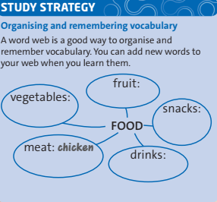

1. *vegetables: chips, salad, beans, carrot, spinach, …*

*2) fruit: apple, mango, orange, pineapple, …*

*3) snacks: nuts, crisps, sweets, pop-corn, …*

*4) drinks: water, fizzy drinks, juice, milk, tea, …*

*5) meat: chicken, beef, pork, lamb, …*

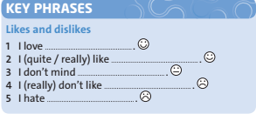

*“Do you like salad?*

* *Yes. I really like salad.*
* *Hmm. I really don’t like salad.*

**II. HOMEWORK:**

* Learn by heart all the new words.
* Workbook: Exercises 1, 2 on page 36.
* Prepare Lesson 2 – Reading.

**Week: 21**  **Planning date: 24/01/2022 – 29/01/2022**

**Period: 62**

**UNIT 5**

**LESSON 2: READING: SUMO WRESTLERS**

**I. NEW WORDS:**

* dessert (n) **/dɪˈzɜːt/**
* train (v) **/treɪn/**

Ex: *I train in the gym for two hours a day.*

* enormous (adj)**/ɪˈnɔːməs/**

Ex: *Their garden is enormous.*

* bowl (n) **/bəʊl/**
* vitamin (n) **/ˈvɪtəmɪn/**
* dish (n) **/dɪʃ/**

**II. HOMEWORK:**

* Read Skill Strategy.
* Workbook: Exercises 1,2 page 40.
* Draw and color a picture of your favourite food.

**Week: 21**  **Planning date: 24/01/2022 – 29/01/2022**

**Period: 63**

**UNIT 5**

**LESSON 3: LANGUAGE FOCUS:**

**COUNTABLE AND UNCOUNTABLE NOUNS – SOME / ANY / MUCH / MANY / A LOT OF**

**I. GRAMMAR**

**1. Many / Much**

**MUCH** + Uncountable nouns

**MANY** + Plural countable nouns:

*Example*

*a.* How many eggs?

*b.* How much bread?

**2.** **A LOT OF** + Plural countable nouns

& uncountable nouns

*Example*

*a.* I need **a lot of** coffee.

b. She has **a lot of** friends.

**3. SOME/ANY** + Plural countable nouns

& uncountable nouns

|  |  |  |
| --- | --- | --- |
| **SOME** | **+ Affirmative** | * We’ve got **some** cheese |
| **ANY** | **- Negative**  **? Question** | * We haven’t got **any** cheese. * Have we got **any** cheese? |

**II. HOMEWORK:**

* Learn by heart all Grammar points.
* Workbook: Exercises page 37